|  |  |  |
| --- | --- | --- |
| Feature Comparison | Bitcoin Treasury Companies and Bitcoin Banks | Bitcoin Lightning Banks |
| Financial Products | Centralized Finance (CeFi) | Centralized and Decentralized Finance (CeFi & DeFi) |
| Financial Rails | Traditional | Traditional and the Bitcoin Lightning Network |
| Financial Management | Custodial | Custodial and non-custodial |
| Financial Markets | National market limitations | DeFi is globally accessible |
| Interest Rate Makers | Company | DeFi is an open and free market |
| Bitcoin Participants | Company | Bank, Fiat Investors, and Bitcoin Investors |
| Bitcoin Yield Distribution | **Concentration within Company** | **Distributed fairly between market participants** |
| Bitcoin Liquidation Risk | **Concentration within Company** | **Distributed between Stable Providers** |
| Bitcoin Liquidation Priority | **Bond holders are paid first** | **Bank is paid first by liquidated Stable Providers** |
| Bitcoin Service Fees | **None** | **Bitcoin-denominated liquidity service fees** |
| Bitcoin Strategy Tools | **Profit, Stock, Debt, and Bitcoin Treasury** | **Same + Bitcoin TVL to defend Bitcoin Treasury** |
| Bitcoin Total Value Locked Growth Rate | **CeFi = 1 Bitcoin buy adds 1 Bitcoin to BTC TVL**  **500K BTC buys 500K BTC TVL in Custody** | **DeFi = 1 Bitcoin buy adds 2 Bitcoin to BTC TVL**  **500K BTC buys 1M BTC TVL in Lightning Network** |

|  |  |
| --- | --- |
| Bitcoin Lightning Stable Bonds | |
| Flexible Rates | Fixed or variable rates based on percentage of stable Fiat or Bitcoin CAGR |
| Tax-Deductible | Interest payments are tax-deductible bank expenditures |
| Securable | Bitcoin is stored in unique Stable Channels to extract yield |
| Callable | If Bitcoin overperforms then the bond can optionally be paid back |
| Extendible | If Bitcoin underperforms then the bond can optionally be extended |
| Non-Convertible | Share dilution is not necessary due to the superior yield |

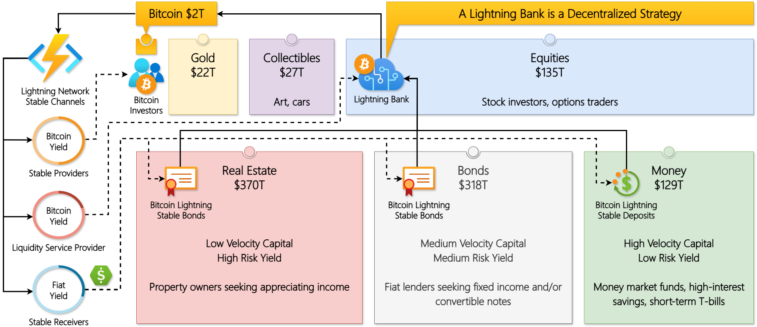**.**

|  |  |  |  |  |  |
| --- | --- | --- | --- | --- | --- |
| Use Cases | | Centralized Finance (CeFi) | Decentralized Finance (DeFi) | | |
| **Custodial** | **Non-Custodial Stable Receiver** | **Non-Custodial Stable Provider** | **Non-Custodial** |
| Stable Channel | Stable Receiver | Lightning Bank | Fiat Investors | Lightning Bank | Fiat Investors |
| Stable Provider | Lightning Bank | Lightning Bank | Bitcoin Investors | Bitcoin Investors |
| Lightning Bank | Goal | Store Bitcoin that was procured from liabilities (ex: bonds, preferred stock) into a Stable Receiver and/or Bitcoin Treasury into a Stable Provider then provide liquidity services to extract and distribute yield | | | Provide liquidity services to extract and distribute yield |
| Fiat Investor | Goal | Purchase TradFi products to earn interest or dividends | Self-custody Bitcoin in Stable Channel for greater control | **Purchase TradFi products to earn interest or dividends** | **Self-custody Bitcoin in Stable Channel for greater control** |
| Risk | Low | Low | **Low** | **Low** |
| Reward | High | High | **Maximum** | **Maximum** |
| Bitcoin Investor | Goal | Send Bitcoin to Lightning Bank to manage the 2X Leverage Long Stable Channel while maintenance is required to avoid liquidation | | **Self-custody Bitcoin in 2X Leverage Long Stable Channel while maintenance is required to avoid liquidation** | |
| Risk | High | High | **High** | **High** |
| Reward | High | High | **Maximum** | **Maximum** |